

SyR-e (Synchronous Reluctance evolution)
Version 1.6 draft
User’s Manual
March, 24 2017

This document is a “work in progress” written to give some basic guidelines to start using SyR-e. As the software evolves we try to keep the manual up-to-date. We apologize for any error or omission and encourage the reader to notify us. Thank you for dedicating your time to our work.
Francesco Cupertino (francesco.cupertino@poliba.it)
Gianmario Pellegrino (gianmario.pellegrino@polito.it)

Introduction

What is SyR-e
SyR-e stands for Synchronous Reluctance – evolution and is an open-source (*)code developed in Matlab/Octave. SyR-e can design synchronous reluctance machines automatically by means of finite element analysis and multi-objective optimization algorithms.
SyR-e is available for download at http://sourceforge.net/projects/syr-e/ .
It requires Matlab or Octave and FEMM software installed. Among the Octave distributions, the one which was tested with SyR-e is Octave UPM (Politechnic University of Madrid). Octave UPM is a customized version of GNU Octave compiled with GUI. The recommended FEMM version is 4.2, released on November 15 2013 (http://femm.info). The Matlab version used at the time of this report is R2013a.
The principle of operation of SyR-e is represented in Fig. 1. A Matlab script realizes a parameterised drawing of a synchronous reluctance machine as a .fem file that is quickly analysed by FEMM. The main results move back to Matlab for performance evaluation. This basic data flow can be used for automatic design purposes, with hundreds of potential machines tested by the multi-objective optimization algorithm, or for the analysis of existing machines, either the just optimized ones or other that are manually designed by the user. GNU Octave can replace Matlab for all mentioned purposes.

(*) LICENSE: The C++ programs based on the original FEMM source code are licensed under the Aladdin Free Public License, as the original FEMM source is also provided under this license. The Matlab/Octave code is provided under the Apache Version 2.0 license. Further details and the texts of these licenses are provided with the source.
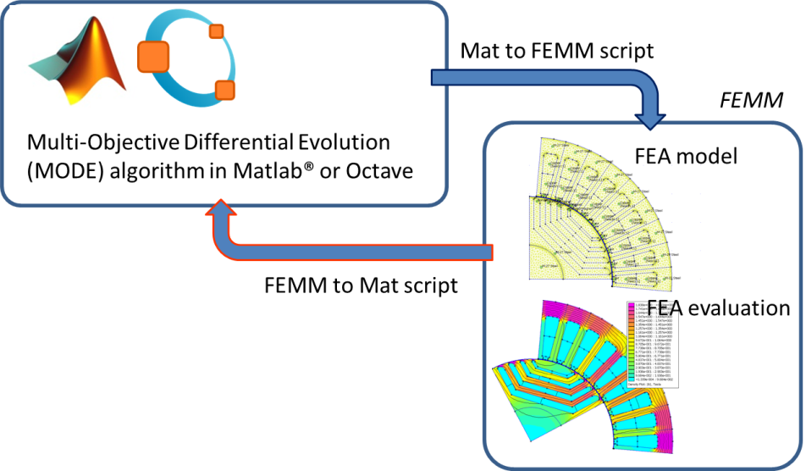
Figure 1 - Data flow to evaluate machine performances

Background
SyR-e is not a commercial software and therefore no technical support is guaranteed. This User Guide gives to the reader the basic information so to allow a first use of SyR-e but it is not intended as a designer manual. SyR-e has been developed over the last few years and used to realize several designs and prototypes. The main technical details about the chosen design methodology can be found in [1] and [2]. The reader is encouraged to refer to related literature for more technical details on the design of synchronous reluctance machines.
The origin of SyR-e, dated back in 2009, was motivated by a twofold vision: 1) to investigate SyR rotor geometries with no prejudices from the existing literature and, 2) to provide an automatic design tool to non-expert designers. These two aspects are still the foundation of the current release, although the work in between has demonstrated that the SyR-e designed geometries are quite consistent with the previous literature.
To summarize the work done so far, different multi-objective optimization algorithms (MOOA) have been compared in [1]. It was shown that multi objective differential evolution (MODE) can guarantee superior performances In terms of speed of convergence and quality of the final result when compared with other state-of-the-art algorithms. The current SyR-e distribution embeds an open source version of the MODE algorithm, but this can be easily substituted with any other algorithm provided that it runs in Matlab/Octave and it is configured to manage the same input/output variables.
Originally, the first version of SyR-e can design only two types of rotor barriers: the circular ones and the segmented ones (all shown in [2]). In the latest versions, the fluid geometry of the flux barriers (explained in [4]) and the SPM rotor are added.

Static Magnetic Solver
Since FEMM is able to solve magneto-static problems, the transient behavior of the machines is usually approximated with a sequence of static simulations in which the rotor position and current phase angles are modified so to emulate their actual behavior. This procedure will be hereinafter referred as static time stepping and needs the number position (geo.nsim) and the corresponding rotor angular excursion (geo.delta_sim) to be determined.

Getting started

FEMM installation
FEMM must be installed before running SyR-e, including OCTAVEFEMM support. OCTAVEFEMM is installed automatically with FEMM, typically in the directory c:\Program Files\femm42\mfiles. This path needs to be added to Matlab/Octave search path by typing the following lines at Matlab/Octave command prompt:
addpath(’c:\\progra˜1\\femm42\\mfiles’);
savepath;

SyR-e files
The SyR-e files must be copied in a single directory, for example c:\SyR-e. SyR-e must be launched from its root folder, e.g. the user must set the Matlab/Octave current folder to the SyR-e installation directory by typing the following line
cd C:\SyR-e

SetupPath
Run the script “setupPath.m”. This will include in the Matlab/Octave path all the SyR-e subdirectories needed for machine analysis on a permanent basis. After the first time, you do not need to launch setupPath.m anymore. However, if the user move SyR-e to a different home directory, the previous paths needs to be manually removed from Matlab/Octave search path and “setupPath.m” needs to be re-executed from the new directory.

Matlabpool: cluster on a single computer
Those Matlab users having the “Parallel Computing Toolbox” installed can execute the command matlabpool to enable the parallel execution of “for” loops (the key command is parfor). From Matlab R2014a on the parpool command has substituted the matlabpool one. For more information about this feature, please refer to Matlab documentation. What happens on a single computer is that multiple FEMM instances are run in parallel. Their number depends on the number of microprocessor cores (workers) of the specific computer.
Matlab users who also have the MATLAB Distributed Computing Server installed can distribute the FEA simulations on a cluster of computers connected in a network. For example, a network of 3 computers having quad-core processors can use 12 FEA simulations in parallel, with substantiation shortening of the overall computational time.

Back compatibility
If you have one motor designed with an older version of SyR-e, is possible to open it with the last version of SyR-e. All the missing data will be set to standard values and some messages will appear on the command window. To use the motor (for further optimization or post-processing) is highly recommended to save the machine with the new version of SyR-e.

SyR-e operation with GUI
The easiest way to use SyR-e (only for Matlab users) is through the Graphical User Interface (GUI), launched by GUI_Syre.m. In the GUI, there are some windows, with all the key parameters of one motor. The first five windows are used for the design, the sixth windows is for the optimization and the last window is for the post-processing.
For the Octave users or for the advanced users, is possible to use SyR-e without GUI, with the same features described in this paragraph.

Manual design
This section describes the use of all the parameters editable via the GUI (or using manual_dataSet for the advanced users). As said, the GUI is launched by running GUI_Syre.m. The input data procedure is organized in five sections:
- Main data (e.g., number of pole pairs, number of slots, …)
- Stator & Rotor Geometry (e.g., tooth length, slot opening, ….)
- Other options (e.g. permitted joule losses, overspeed, …)
- Windings (e.g. filling factor, turns in series, coil span, …)
- Materials (e.g., stator and rotor materials)
For each parameter of the GUI there is an input field accompanied by the parameter’s name, its dimension in square brackets and the name of the corresponding Matlab variable in round brackets. When the GUI is launched, the default values of all parameters are taken from the mot_01.mat.

Main data window
The main data window represented in Fig. 3 is the default one after the launch of GUI_Syre.m. This window allows to select the number of pole pairs (geo.p), the number of stator slots per pole and per phase (geo.q), the airgap thickness (geo.g), the stator outer radius (geo.R) and the airgap radius (geo.r), the shaft radius (geo.Ar), the stack length (geo.l) and the type of rotor geometry (Circular, Seg, ISeg, Fluid and SPM). For more details about rotor geometry and its parameterization, please refer to [2], [4].
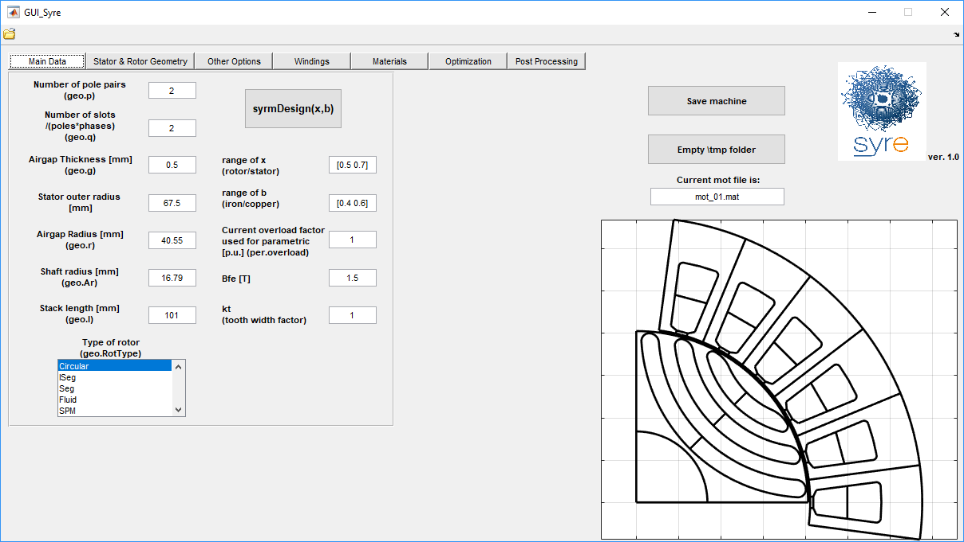
Figure 2 - Main data window

Stator & Rotor Geometry window

Synchronous reluctance machine
The window is split in two parts related to stator and rotor parameters respectively. The left part (stator geometry) allows to select the tooth length (geo.lt) and width (geo.wt), the slot opening in p.u. of the slot pitch (geo.acs) and some details of the slot geometry. In particular, it is possible to modify thickness of the tooth shoe (geo.ttd), the angle of the connection between the tooth shoe and the tooth shank (geo.tta), and the fillet radius at the back corners of the slot (geo.SFR).
The right part of the window is for the parameters of the rotor geometry. If the rotor is a SyR type (Circular, ISeg, Seg and Fluid) you can select the number of rotor barriers (geo.nlay), the angles describing the barrier positions at the airgap (alpha) and their thicknesses (hc), the translation of the barrier along the q axis (geo.dx) and the dimension of the radial ribs (geo.pont). The last four parameters are vectors of geo.nlay elements. Figure 4 clarifies the definition of Δα_{i} (i=1,2,…n_{lay}) angles and hc_{i} (i=1,2,… n_{lay}) thicknesses. The angle of the first barriers is defined starting from the middle point of the pole while the other angles are defined as the angular displacement between two consecutive barriers. This choice is adapted to the use of a per unit representation of the Δα_{i} (i=1,2,… n_{lay}) angles being the angle subtending half pole pitch the base value. Also the thicknesses hc_{i} (i=1,2,… n_{lay}) can be represented conveniently in per unit values. If they are all 1 p.u. then the barriers are thick the same and occupy as much radial space as they can. A minimum thickness of the flux guides is fixed to guarantee rotor mechanical feasibility and avoid overlapping barriers. When all the p.u. heights are of a different value, e.g. 0.2, then the barriers are again thick the same with a value that is the 20% of the previous example. All other situations are combination of the previous ones. Angles and thicknesses are input in per unit but the actual values in degrees and millimetres are immediately calculated and displayed.
The translation of the barrier along the q-axis is expressed in p.u. with reference of the hc. This parameter is not available for the ISeg geometry. Each barrier can have a different dx, and figure 5 show three rotor lamination with different dx (all the barrier in this example have the same dx, but is possible to have different dx for each barrier). To note that the shape of the end-barrier arcs change with dx, because the thinner points of the radial ribs are defined by the alpha parameters, and for the three example, it is the same. (see “2016 08 30 - added dx in circ geometry.pptx” in ReadMe folder).
The radial ribs with usually are evaluated using the “Overspeed” parameter (in other option tab), but in some case can be useful to set manually the dimension of the radial ribs. To enable this feature, the tick near this field must be set.
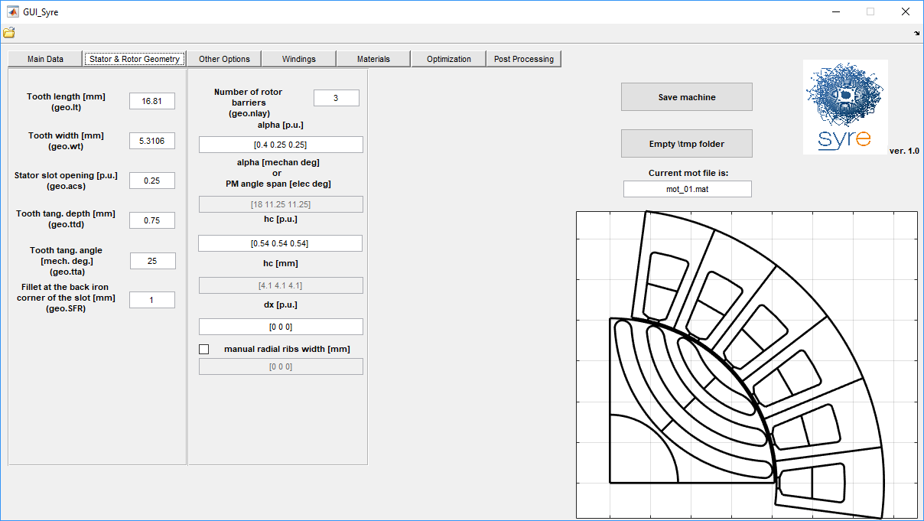
Figure 3 - Stator geometry window
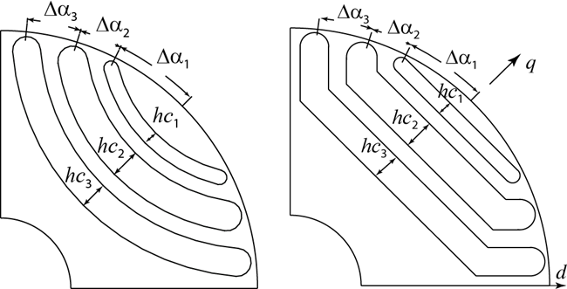
Figure 4 - Definition of Δα_{i} angles and hc_{i} thicknesses for circular (left) and segmented (right) rotor geometries in case of three rotor barriers

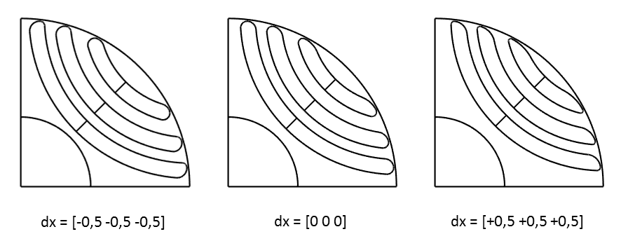
Figure 5 - Difference of dx setting in the barrier design: -0.5 (left), 0 (center) and +0.5 (right).

SPM machine
If the rotor type is SPM, the input are the PM angle span (expressed in electrical degree), the magnet width (hc [mm]) and the number of segment of the magnet (for this last input, use the dx field). If dx = 1, the magnet is parallel magnetized. While radial magnetization is needed, define dx as 20 or more.
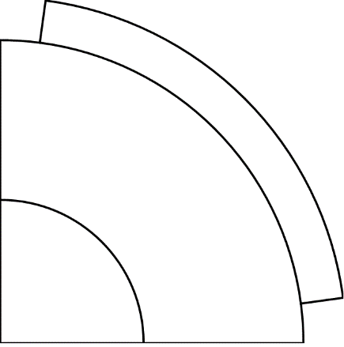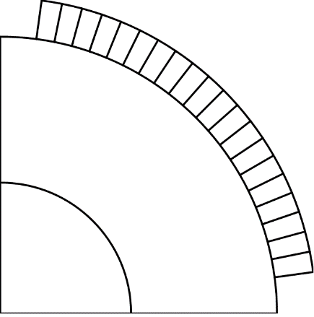
Figure 6 - Parallel and radial magnetization

Other Options window
The continuous stall loss (per.Loss) is the input data that defines the rated loading of the machine. The motor rated current, called i₀, is calculated accordingly (per.loss = 3Ri₀²). The evaluation of i₀ from the loss input requires that the phase resistance is estimated, on the basis of stator geometry and winding layout, and including the active parts and end-connections length.
The overload factor per.overload defines the machine loading used for the automatic design, in per unit of the rated current level i₀. The single current level used during the optimization is given by the “current overload factor” times i₀. In principle, the current overload factor could be any positive real number, also lower than one. Machines optimized in overload conditions tend to perform well also below rated current, and not vice-versa.
The target copper temperature (per.tempcu) is the one used to estimate the coils resistance and determine i₀ from per.loss. The Housing temperature is used to evaluate the estimated copper temperature with an easy thermal model [10].
Overspeed is the maximum expected rotational speed and used to size the radial ribs. The calculation is made considering the centrifugal force at steady state and disregarding the magnetic pull and the structural effect of the tangential ribs at the airgap [3]. If the thickness of the calculated radial ribs falls below the minimum mechanical tolerance defined by geo.pont0 (that is the last parameter defined in the current window), then the radial ribs are disregarded (as it is the case in Fig. 5). The thickness of the tangential ribs defined by geo.pont0. As said, their presence is disregarded during radial ribs sizing.
Mesh and Mesh MOOA are two variables that control the density of the mesh in the finite element problem (used by file mfiles\dimMesh.m). There are two different mesh resolution to set: a general mesh resolution and the airgap mesh resolution. Usually, during the optimization, the mesh is coarser than the post-processing. In Table 1, the equations to obtain the resolutions are reported for both cases.
Table 1 - Mesh resolution definitions
 | During optimization | During post-processing
General mesh resolution | $$\frac{Mesh_MOOA}{p}$$ | $$\frac{Mesh}{p}$$
Airgap mesh resolution | $$\frac{1}{p}$$ | $$\frac{Mesh}{p∙Mesh_MOOA}$$
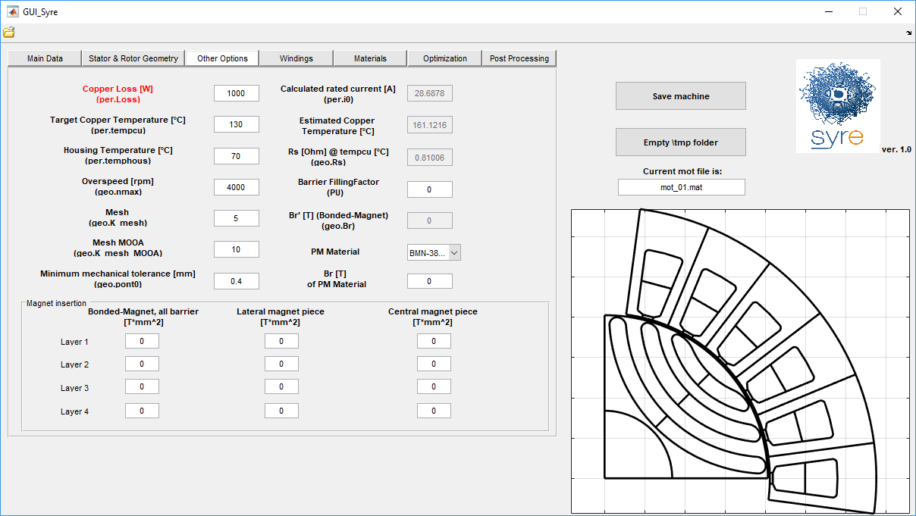
Figure 7 - Other options window

Synchronous reluctance machine
The Barrier Filling Factor is used only with Circular flux barrier to define how much the barrier are filled with the magnet (defined in the Material Tab). The input can be a number (all the barriers uses the same value) or a vector of geo.nlay elements. If the Barrier Filling Factor is equal to 1, the barrier is filled, and there are air only in the end of the barrier, while if this parameters is equal to 0, the barrier is completely filled by the magnet.

SPM machine
The Barrier Filling Factor is as the shaping factor of magnet. When it is unity, the magnet surface is uniform. If it is less than unity, magnet shaping technique is applied on its outer surface. The detailed illustration is presented in [14].
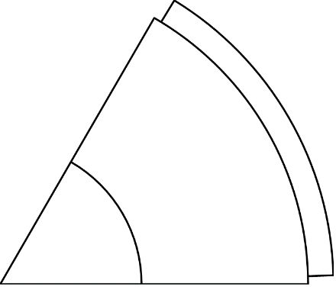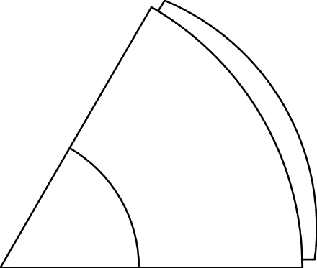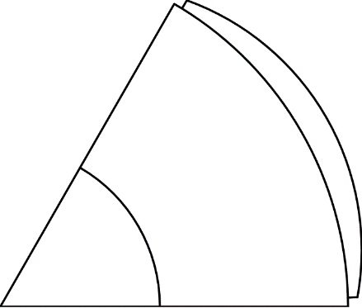
Figure 8 – Manget shaping, $β=1, 1/2, 1/3$
A similar feature is implemented for Seg and ISeg geometries with the “Magnet Insertion” inputs. These are enabled if “Bonded-Magnet” is selected, and the equivalent Flux Density*area is evaluated for each barrier with Bonded Magnet and the selected remeance, or with a real magnet (Input “PM material”) and the selected magnets areas.
The last parameter is the remanence (Br) of the magnets in [T]. This input can be a number or a vector (like the previous input) and is editable only if the magnetic material selected is a virtual magnet (“Bonded-Magnet”). If the flux barrier material is a real magnet, the input are disabled, and it is show the remanence value of the magnet. If you want to change this value for the simulation, see the Post Processing Tab.

Windings window
The copper filling factor (geo.kcu), the number of turn in series per phase (geo.Ns) and the shortening factor (geo.Kracc) are input in this window. If n_{sh} is the number of slots by which the winding is shortened and n_{fp} is the number of slots covered by the full pitch winding, the shortening factor is defined as (n_{fp}-n_{sh})/n_{fp}.
There is a table for visualization of the winding layout. The table has two rows, corresponding to the inner and outer layers of the windings, respectively. Single and double layer windings are feasible in this release of SyR-e. The number of columns is equal to the number of slots represented in the machine sketch to the right end of the GUI. The first column (Slot n° 1) corresponds to the slot on the horizontal axis and so on, in counterclockwise direction. The numbers 1, 2, 3, -1, -2, -3 in the table refer to the position of the conductors of the three phases in the slots. Their positive and negative signs determine the direction of the phase current into the slot. Single layer windings are a subcase of double layer ones: when the two numbers corresponding to each single slot are equal, a single layer winding will be represented.
Every time geo.q or geo.Kracc are changed, the winding table is recalculated using a version of Koil software (http://koil.sourceforge.net/ by Luigi Alberti) purposely rebuilt to work with SyR-e under Windows operating systems and distributed with SyR-e package. It is always possible input the numbers in the table manually and customize the winding layout. It is recommended to use the “SAVE CONFIGURATION” button after each change of windings parameter, to make the manual modifications effective.
It is possible also design a stator with multiple three-phase sets, by setting properly the related input. About the winding, the numbers of the phases follow the original one, e.g.: [4,5,6] for the second set, [7 8 9] for the third set and so on. The winding configuration must be saved with “Save Configuration” button.
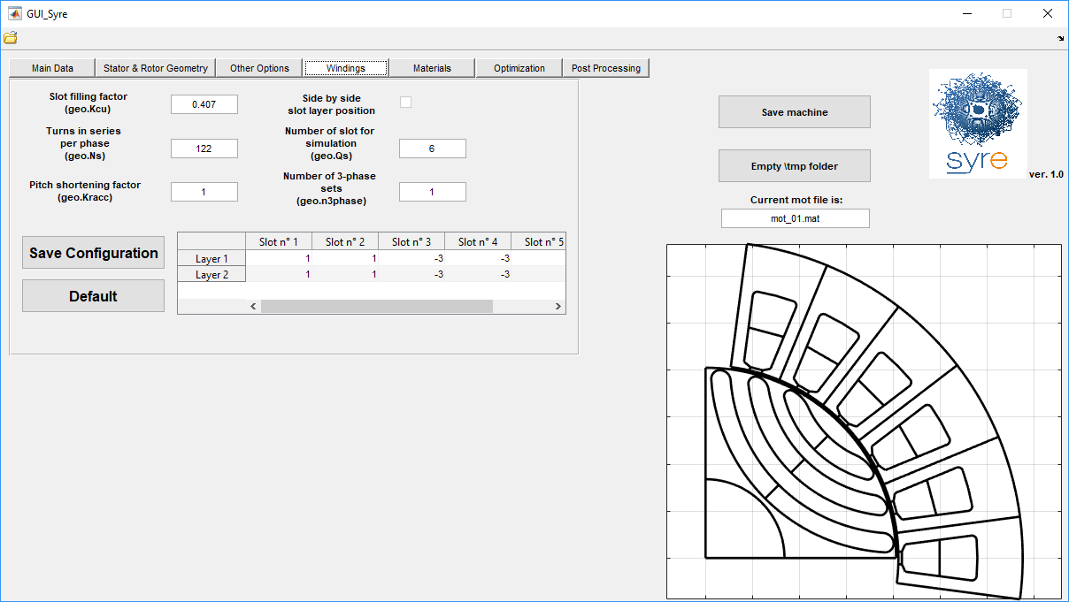
Figure 9 - Windings window
For example, two slots per pole per phase (geo.q = 2) and no shortening (geo.Kracc = 1). The table says:
1 1 -3 -3 2 2
1 1 -3 -3 2 2
A chorded, double layer version is (Kracc=5/6):

1 1 -3 -3 2 2
-2 1 1 -3 -3 2, or alternatively
1 1 -3 -3 2 2
1 -3 -3 2 2 -1
Phase permutations have no effect because the offset between the three phase windings and the rotor in position zero is calculated automatically.
The parameter Qs is the number of slots to use in the simulation. It can be varied for the non-conventional winding machines, with an increase of the computational time of FEMM. The default value is the minimum allowed.
If the designed machine is a fractional slot machine, the “slot layer position” tick can be selected to design layer in the coil tooth style.

Materials window
In the material tab you can set the material for slots, stator core, rotor core, flux barrier, shaft and rotor conductor (this field was used in some older version of SyR-e, but now is not used). The material library is organized with one window (used to display the material names) and four buttons, used to show the names of iron material available, conductor material available, flux barrier material available and to show the properties of materials (button “View Prop”). The material database is stored in three .m files (one for each type of material) and if you want to add custom materials, you must edit these files.
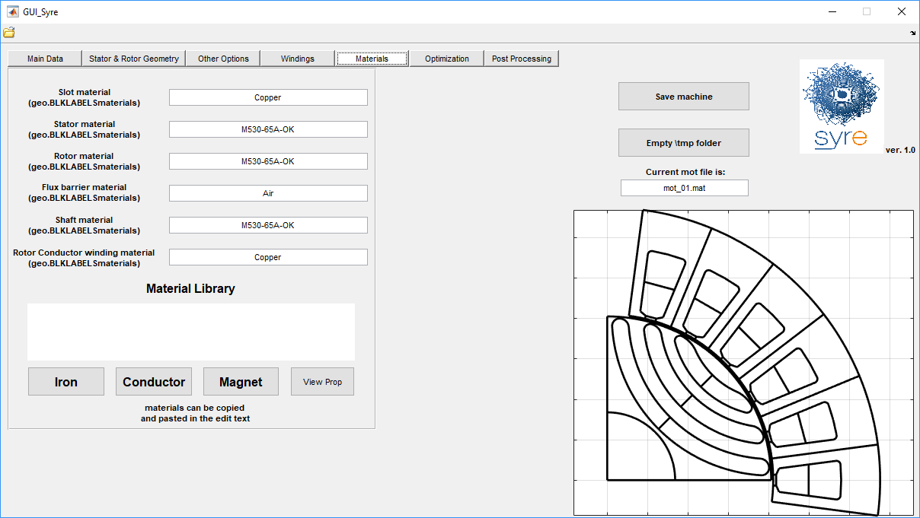
Figure 10 - Materials window

Preview and save a single machine
Every time a parameter is modified a preview of the machine appears in the right side of SyR-e window. The “Save Machine” button allows to save the current machine configuration. Two files are created, a .mat file containing the current data set and a .fem file that is the machine model for finite element analysis with FEMM. The .mat file can be reloaded at any time using the open button at the top left corner of SyR-e window. The FEMM model can be run manually or with the aid of the SyR-e “Post Processing” window.
“Empty \tmp folder” deletes all the files in the subfolder \tmp. Many files are temporary stored is this folder during optimization, and it is the good practice to empty the folder before each optimization run.

Automatic design with parametric analysis
In the main data window, there is also the “syrmDesign” button, which perform a parametric design of SyR motor according to [11] and SPM motor according to [12]. The parameters of the analysis are the split ratio x defined as the ratio between rotor and outer stator radius and the induction ratio b defined as the ratio between the peak of the airgap flux density and the peak flux density in the stator iron. For the SPM motor, instead of this parameter, the ratio between the length of the PM over the airgap width.
Before to start the parametric analysis, the user must set the main data of the machine, plus the boundary of the parameters, the overload current during the analysis, the induction in the stator yoke iron (Bfe) and the tooth factor (kt) that define how the stator teeth are narrow.
When the user push the syrmDesign button, the contour plot of torque and power factor appear in the x-b plane (or x-lm/g plane) and a machine can be selected and saved pushing on the preferred point of the plot.

Execution of the Optimization
During the optimization, some stator and rotor parameters are automatically modified, in order to reach the best in term of some objective. The optimization process consist of two parts: the evolution process and the re-evaluation of the Pareto front, with better accuracy than the evolution process. Before pushing the “Optimize” button and start the optimization, three type of input must be set:
- Optimization algorithm parameters
- Optimization variables
- Optimization objectives
Before to start the optimization, remember to delete the \tmp folder.

Optimization parameters
The multi-objective algorithm used for the optimization is a variant of the well-known Differential Evolution described in [9]. On the left of the Optimization tab there are the optimization setting, which are the number of generation of the evolution process and the number of the population for each generation. In addition, the angle span and the number of simulation for the evaluation of the performance of each candidate must be set (see [1] for more details). The evaluation parameters can be different for the evolution process and the final evaluation of the Pareto front and are all settable in the Optimization tab. The overload current to use in the optimization process can be set on the left of the optimization tab. Using a quite high overload current during the optimization (e.g. 2) can guarantees a lower torque ripple both at rated current and at overload current [1].

Optimization variables
The optimization variables are the geometrical parameters that the optimization algorithm change during the evolution process. They are:
- Flux barrier angles (for SPM, is the angle span of the magnet)
- Flux barrier thickness (for SPM is the thickness of the magnet)
- Translations along the q-axis (not used for SPM)
- Airgap thickness
- Airgap radius
- Tooth width
- Tooth length
- Stator slot opening
- Tooth shoe thickness
The last optimization variable is gamma (γ), which are the angle between the current vector and the d-axis (maximum permanence axis). Each motor is evaluated using a single current angle At the end of the optimization γ is expected to be very close to the Maximum Torque per Ampere (MTPA) angle condition γ_{MTPA}, which is the one maximizing the torque per Joule loss.
For each variable are present one checkbox, to use or not use the variable in the evolution process and a text-box, with the lower and upper boundary of the variable.
In the definition of the search bounds and the number of variables to be included in the optimization process some preliminary test should be realized so to verify that the chosen search space does not contain unfeasible machines. For example, the sum of rotor radius and tooth length should be lower than the stator radius. This kind of checks are not executed automatically by SyR-e then a particular care must be used in the definition of bounds. A suggestion could be to start with bounds close to a machine with known performances so to gain experience and confidence with the software.

Optimization objectives
The optimization objectives define which individual are good and which are not good. The objective actually available are:
- Maximum torque
- Minimum torque ripple, which is the peak-to-peak torque ripple. In the past was used the standard deviation of the torque divided by the medium torque.
- Minimum copper mass
Each objective has one check box (to select the objective for the evolution process) and one textbox, to set the maximum wanted value. During the evolution process, all the motors that have their performance higher than the maximum value set are penalized. This discourages the optimization algorithm to further search in not promising regions of the search space.

Optimization results
At the end of the optimization, a .mat file and a folder are created in the \results folder named according to the scheme OUT_dateTtime where date and time are taken when the optimization ends. The OUT_dateTtime.mat file contains the data set used to launch the optimization and a data structure called OUT with the main optimization results (Pareto front solutions and their performances). In the \results\OUT_dateTtime folder there are the .fem files relative to the final Pareto front machines, the .bmp images representing the same machines and some .fig files reporting the Pareto front and the values of the optimization variables of the optimized machines.
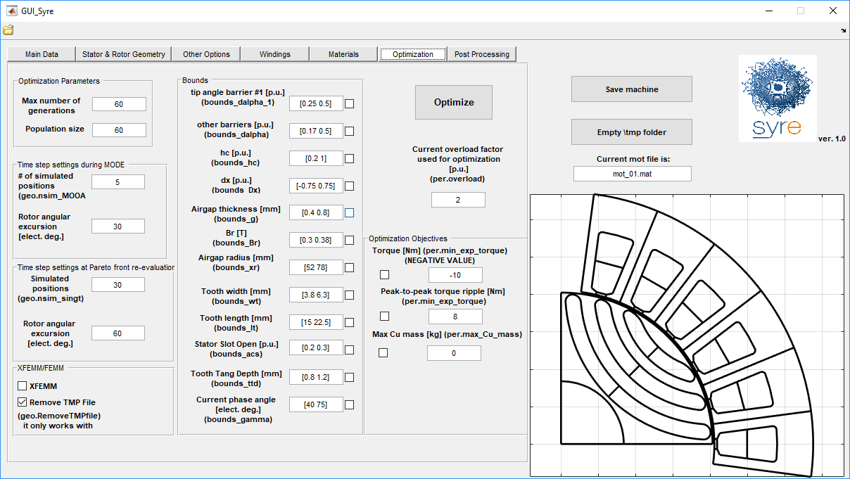
Figure 9 - Optimization window

SyR-e post processing
The post processing is executed using the last SyR-e window. The main parameters to enter are the ”rotor angular excursion” that is the angular span of the static time stepping in electrical degrees, the “current phase angle” in dq coordinates and the “number of rotor positions” that is the number of equally spaced rotor positions that will be simulated over the previously defined angular excursion. Moreover, the “current load” is the per unit current level used in the analysis, being the current i₀ defined on the basis of the admissible joule losses at stall the base current value. Permanent magnets having residual flux density specified by “Br” can be included in the rotor barriers. Note that the radial ribs are not re-calculated considering permanent magnet mass during the post processing because the analysis will be executed starting from an existing .fem file.
There are three types of post-processing which SyR-e can perform:
- Single point evaluation
- Multiple point evaluation
- Flux and torque maps evaluation

Single point evaluation
This is the standard evaluation of SyR-e: the machine is simulated with one condition of current, with the set rotor angular excursion and number of rotor position. The results of the evaluation are the fluxes, the torque and the internal power factor. In figure 10, an example of the results.
Figure 10 - Post Processing results in case of the analysis for a single current level and phase angle: torque and power factor (first column) and dq fluxes (second column).

Multiple point evaluation
This type of evaluation is quite similar to the standard one. The difference in that in this configuration, the overload and the gamma in vector of equal dimension and each element define a single point evaluation. The output are the same as the single point evaluation, plus torque, torque ripple and fluxes in function of the simulations.

Flux and torque maps evaluation
In this evaluation, a grid of id and iq is used to evaluate the motor. The grid is a square grid and the maximum value (for id and iq) is the overload current and the number of points for each side of the grid is defined by the last parameter in this window (“number of points in [0 Imax]”). To enable this function, the gamma must be set equal to 1000 (is a conventional number not related to current phase). At the end of post processing the results (average torque, torque ripple, and dq fluxes over the i_{d}-i_{q} plane) are interpolated in Matlab and displayed with a finer resolution. In figure 11 an example of the results.
Figure 11 - Post Processing results in case of the detailed analysis in the id-iq plane: dq fluxes (first column), average torque and torque ripple (second column).

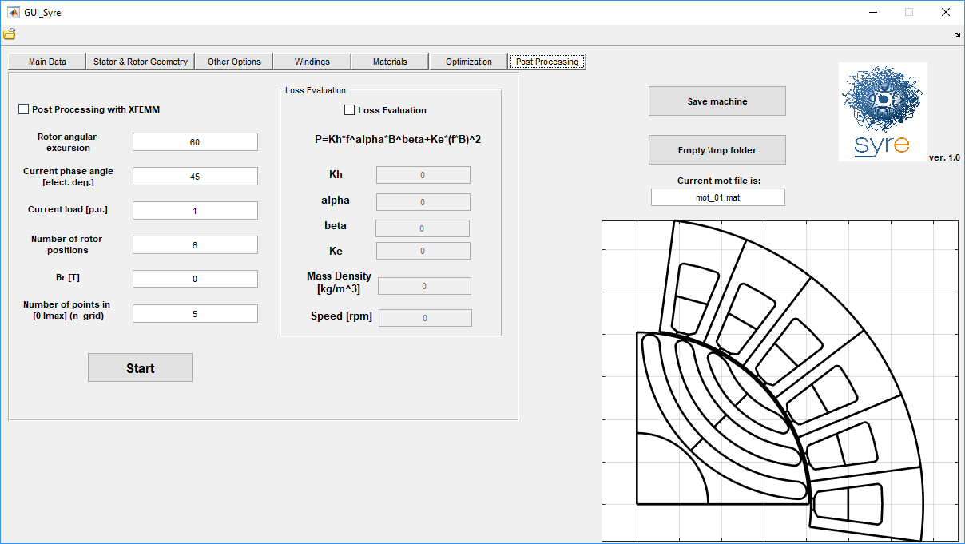
Figure 12 - Post Processing window

Iron loss evaluation
When the loss evaluation option is ticked, the parameters on iron and motor speed can be editable as input. Steinmetz Equation is used to evaluate iron losses.
$$P=k_{h}f^{α}B^{β}+k_{e}{(fB)}^{2}$$
The frequency is relate to rotor speed, other parameters are the input from GUI.
Fast FEA method is used in SyR-e for iron loss calculation on stator. Therefore, just 1/3 stator iron elements are counted. Moreover, only 6 positions are evaluated to decrease the time consuming [13]. Periodic computing is applied on rotor to diminish redundant calculation. The loss result is saved in out struct of .mat file.

Offline operation

Manipulation of the simulations results
This set of function (stored in the folder syreManipulateMM) allow to manipulate the result of the flux and torque maps evaluation, obtaining:
- Magnetic model
- Inverse magnetic model
- Maximum torque per ampere (MTPA) and maximum torque per voltage (MTPV) trajectories
- Operating limits on the torque-speed plane

SyR-e export
Standard SyR-e files are in .mat format and .fem format. There are some features to do the automatic export of the motor from SyR-e to other software. The export currently supported are:
- File .dxf: is useful to export the draw in other CAD or FEA software, like MagNet, SolidWorks, AutoCAD, and other. The function is in \syreExport and is called SyreToDxf.
- MagNet: is like the post-processing with FEMM, but use MagNet. First the .dxf file must be created, and then the functions is BuildMachine.m (do create MagNet file) and RUN_SIM.m (to perform the post processing)

Working without GUI
Octave users cannot use the GUI and must find their way to the direct use of the major scripts of SyR-e. Plus the use of SyR-e without GUI can be useful for Matlab users which want to automatize some function of SyR-e. Here the expert user can find the advanced function that allow to use SyR-e without GUI.

manual_dataSet.m
In this script produce a dataSet structure, similar to the one produced by the GUI. Is the input for the no-GUI users.

DrawMachineScript(dataSet,pathname,filename)
This function allow to save the motor described by the structure dataSet in the selected pathname and with the selected filename. If no input are used, the dataSet is evaluated by manual_dataSet.m, the directory is the SyR-e directory and the name is “newmachine.mat”.

MODEstart(pathname,filename)
With this function, you can run the optimization. If you run the function without inputs, the base setting are the ones stored in manual_dataSet.m. Else, if you put a correct pathname and filename, the base motor will be the selected motor, and in MODEstart you can change the parameters of the optimization.

post_proc_single_motor(dataSet)
This function allows running the analysis of an existing motor. For more details, refer to section 3.3.

References
- F. CUPERTINO, G. PELLEGRINO, C. GERADA, “Design of Synchronous Reluctance Motors with Multi-Objective Optimization Algorithms”, IEEE Transactions on Industry Applications, DOI: 10.1109/TIA.2014.2312540.
- G. PELLEGRINO, F. CUPERTINO, C. GERADA, “Automatic Design of Synchronous Reluctance Motors focusing on Barrier Shape Optimization”, IEEE Transactions on Industry Applications, DOI: 10.1109/TIA.2014.2345953.
- PALMIERI M., PERTA M.; CUPERTINO F., PELLEGRINO G. “High-Speed Scalability of Synchronous Reluctance Machines Considering Different Lamination Materials”, IEEE IECON 2014, the 40th Annual Conference of the IEEE Industrial Electronics Society, 29 October - 1 November Dallas (USA).
- M. GAMBA, G. PELLEGRINO, F. CUPERTINO, “Optimal Number of Rotor Parameters for the Automatic Design of Synchronous Reluctance Machines”, ICEM 2014, International Conference ion Electrical Machines, 2-5 September 2014, Berlin, Germany.
- PALMIERI M., PERTA M.; CUPERTINO F., PELLEGRINO G. “Effect of the numbers of slots and barriers on the optimal design of synchronous reluctance machines”, OPTIM 2014, International Conference on Optimization of Electrical and Electronic Equipment, Brasov, Romania 22-24 May 2014, pp. 260-267.
- CUPERTINO F, PELLEGRINO G, ARMANDO E, GERADA C “A SyR and IPM machine design methodology assisted by optimization algorithms”, IEEE ECCE 2012, Energy Conversion congress & EXPO. Raleigh (USA), 15-20 September 2012, pp. 3686-3691.
- G. PELLEGRINO, F. CUPERTINO: “FEA-based multi-objective optimization of IPM motor design including rotor losses”, IEEE ECCE 2010, second IEEE Energy Conversion Congress and Exposition, Atlanta, Georgia, USA, September 12-16, 2010.
- F. CUPERTINO, G. PELLEGRINO: “IPM motor rotor design by means of FEA-based multi-objective optimization”, IEEE ISIE 2010, Bari, Italy, 4-7 July 2010.
- A. Zamuda, J. Brest, B. Boskovi ˇ c, and V. ´ Zumer, “Differential Evolution for Multiobjective Optimization with Self Adaptation,” in 2007 IEEE Congress on Evolutionary Computation CEC 2007. IEEE Press, 2007, pp. 3617–3624.
- A. Boglietti, A. Cavagnino, M. Lazzari and M. Pastorelli, "A simplified thermal model for variable-speed self-cooled industrial induction motor," in IEEE Transactions on Industry Applications, vol. 39, no. 4, pp. 945-952, July-Aug. 2003.
- I. Boldea, T. Fulcao, T.A. Lipo, L. Malesani, T.J.E. Miller, A. Vagati, “Synchronous Reluctance Motors and Drives, A New Alternative,” Tutorial Course
- C. Lu and G. Pellegrino “A Simple Design Method for Surface-mounted PM Machines for Traction Application”, Proc. of IEEE ECCE 2016, 18-22 Sept. Milwaukee (USA).
- G. Y. Sizov, D. M. Ionel and N. A. O. Demerdash, "Modeling and Parametric Design of Permanent-Magnet AC Machines Using Computationally Efficient Finite-Element Analysis," in IEEE Transactions on Industrial Electronics, vol. 59, no. 6, pp. 2403-2413, June 2012.
- C. Lu, S. Ferrari, G. Pellegrino, M. Davoli, C. Bianchini “Parametric Design Method for SPM Machines Including Rounded PM Shape”, IEEE Energy Conversion Congress and Exposition (ECCE), Cincinnati, OHIO, Oct. 1–5, 2017

Acknowledgements
SyR-e was made possible thanks to the contribution of several colleagues, students and friends that collaborated to the development of the project.
A special credit goes to Irene Bedino, author of the original design of the SyR-e logo.

